AP World History 9 Date: ___________________________
Dr. Afxendiou Unit 3: The Postclassical Era
Chapter 10: Civilization in Eastern Europe: Byzantium and Orthodox Europe

Name: ____________________________________________________________________ Period: ______

Directions: Use the reading, your textbook, or internet sources to answer the following questions. Please give full and complete answers.

QUESTIONS:

- Who was Emperor Justinian and what were his achievements? __________________________________________________________________________________________________________________________________________________________________________________________________________________________________________________________________________________________________________________________________________________________________________________________________________________________________________________________________________________________________________________________________________________________________________________________
- Why did the Nika riots take place? __________________________________________________________________________________________________________________________________________________________________________________________________________________________________________________________________________________________________________________________________________________________________________________________________________________________________________________________________________________________________________________________________________________________________________________________
- Describe the Hagia Sophia and explain why it was important.
__________________________________________________________________________________________________________________________________________________________________________________________________________________________________________________________________________________________________________________________________________________________________________________________________________________________________________________________________________________________________________________________________________________________________________________________
- Why do you think the Emperor Justinian put such emphasis in rebuilding the Hagia Sophia in such grand manner? __________________________________________________________________________________________________________________________________________________________________________________________________________________________________________________________________________________________________________________________________________________________________________________________________________________________________________________________________________________________________________________________________________________________________________________________
- Look at the images of the Hagia Sophia below. What do you think this structure expresses about the Byzantine state and economy and about the power of the emperor?

__________________________________________________________________________________________________________________________________________________________________________________________________________________________________________________________________________________________________________________________________________________________________________________________________________________________________________________________________________________________________________________________________________________________________________________________

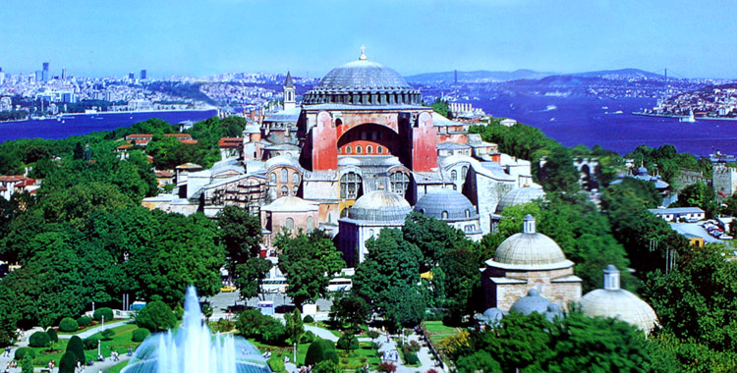
Hagia Sophia with the minarets graphically removed – this is as it would have been seen during the Byzantine Empire
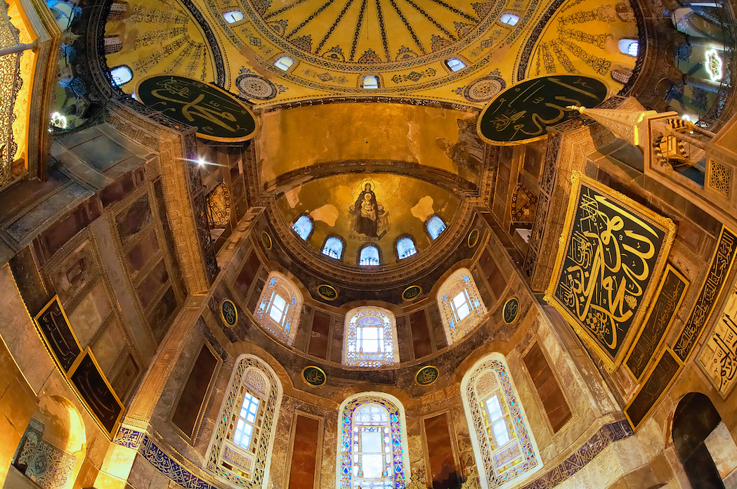
A dome in the Hagia Sophia church

