AP WORLD HISTORY 9 Date: ___________________
Dr. Afxendiou UNIT III – The Postclassical Period

Umayyad Caliphate (661–750)
The Umayyad Caliphate was the second of the four major Arab caliphates established after the death of Muhammad. This caliphate was centered on the Umayyad dynasty, hailing from Mecca. The Umayyad family had first come to power under the third caliph, Uthman ibn Affan (r. 644–656), but the Umayyad regime was founded by Muawiya ibn Abi Sufyan, long-time governor of Syria, after the end of the First Muslim Civil War in 661 CE. Syria remained the Umayyads’ main power base thereafter, and Damascus was their capital.
Under the Umayyads, the caliphate territory grew rapidly. The Islamic Caliphate became one of the largest unitary states in history, and one of the few states to ever extend direct rule over three continents (Africa, Europe, and Asia). The Umayyads incorporated the Caucasus, Transoxiana, Sindh, the Maghreb, and the Iberian Peninsula ( Al-Andalus ) into the Muslim world. At its greatest extent, the Umayyad Caliphate covered 5.79 million square miles and included 62 million people (29% of the world’s population), making it the fifth largest empire in history in both area and proportion of the world’s population. Although the Umayyad Caliphate did not rule all of the Sahara, nomadic Berber tribes paid homage to the caliph. However, although these vast areas may have recognized the supremacy of the caliph, de facto power was in the hands of local sultans and emirs.
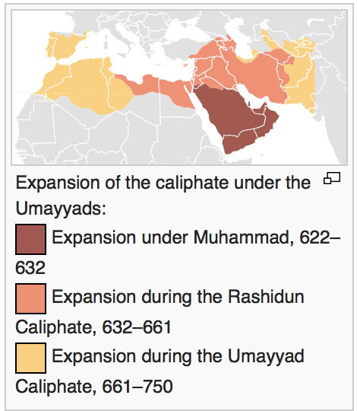
Expansion of the caliphate: This map shows the extension of Islamic rule under Muhammad, the Rashidun Caliphate, and the Umayyad Caliphate

The Umayyad dynasty was not universally supported within the Muslim community for a variety of reasons, including their hereditary election and suggestions of impious behavior. Some Muslims felt that only members of Muhammad’s Banu Hashim clan or those of his own lineage, such as the descendants of Ali, should rule. Some Muslims thought that Umayyad taxation and administrative practices were unjust. While the non-Muslim population had autonomy, their judicial matters were dealt with in accordance with their own laws and by their own religious heads or their appointees. Non-Muslims paid a poll tax for policing to the central state. Muhammad had stated explicitly during his lifetime that each religious minority should be allowed to practice its own religion and govern itself, and the policy had on the whole continued.
There were numerous rebellions against the Umayyads, as well as splits within the Umayyad ranks, which notably included the rivalry between Yaman and Qays. Allegedly, The Sunnis killed Ali’s son Hussein and his family at the Battle of Karbala in 680, solidifying the Shi’a-Sunni split. Eventually, supporters of the Banu Hashim and the supporters of the lineage of Ali united to bring down the Umayyads in 750. However, the Shiʻat ʻAlī, “the Party of Ali,” were again disappointed when the Abbasid dynasty took power, as the Abbasids were descended from Muhammad’s uncle `Abbas ibn `Abd al-Muttalib, and not from Ali.
The Abbasid victors desecrated the tombs of the Umayyads in Syria, sparing only that of Umar II, and most of the remaining members of the Umayyad family were tracked down and killed. When Abbasids declared amnesty for members of the Umayyad family, eighty gathered to receive pardons, and all were massacred. One grandson of Hisham, Abd al-Rahman I, survived and established a kingdom in Al-Andalus (Moorish Iberia), proclaiming his family to be the Umayyad Caliphate revived.

Umayyad Dynasty in Cordoba, Spain
The revival of the Umayyad Caliphate in Al-Andalus (what would become modern Spain) was called the Caliphate of Córdoba, which lasted until 1031. The period was characterized by an expansion of trade and culture, and saw the construction of masterpieces of al-Andalus architecture.
The caliphate enjoyed increased prosperity during the 10th century. Abd-ar-Rahman III united al-Andalus and brought the Christian kingdoms of the north under control through force and diplomacy. Abd-ar-Rahman stopped the Fatimid advance into caliphate land in Morocco and al-Andalus. This period of prosperity was marked by increasing diplomatic relations with Berber tribes in north Africa, Christian kings from the north, and France, Germany, and Constantinople.
Córdoba was the cultural and intellectual center of al-Andalus. Mosques, such as the Great Mosque, were the focus of many caliphs’ attention. The caliph’s palace, Medina Azahara, was on the outskirts of the city, and had many rooms filled with riches from the East. The library of Al-Ḥakam II was one of the largest libraries in the world, housing at least 400,000 volumes, and Córdoba possessed translations of ancient Greek texts into Arabic, Latin and Hebrew. During the Umayyad Caliphate period, relations between Jews and Arabs were cordial; Jewish stonemasons helped build the columns of the Great Mosque. Al-Andalus was subject to eastern cultural influences as well. The musician Ziryab is credited with bringing hair and clothing styles, toothpaste, and deodorant from Baghdad to the Iberian peninsula. Advances in science, history, geography, philosophy, and language occurred during the Umayyad Caliphate as well.
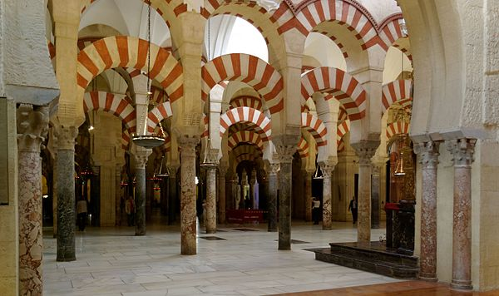
Mosque: Interior of the Mezquita (Mosque), one of the finest examples of Umayyad architecture in Spain.

Legacy of the Umayyad Caliphate
The Umayyad caliphate was marked both by territorial expansion and by the administrative and cultural problems that such expansion created. Despite some notable exceptions, the Umayyads tended to favor the rights of the old Arab families, and in particular their own, over those of newly converted Muslims (mawali). Therefore, they held to a less universalist conception of Islam than did many of their rivals.
During the period of the Umayyads, Arabic became the administrative language, in which state documents and currency were issued. Mass conversions brought a large influx of Muslims to the caliphate. The Umayyads also constructed famous buildings such as the Dome of the Rock at Jerusalem and the Umayyad Mosque at Damascus.
According to one common view, the Umayyads transformed the caliphate from a religious institution (during the Rashidun) to a dynastic one. However, the Umayyad caliphs do seem to have understood themselves as the representatives of God on Earth.
The Umayyads have met with a largely negative reception from later Islamic historians, who have accused them of promoting a kingship (mulk, a term with connotations of tyranny) instead of a true caliphate (khilafa). In this respect it is notable that the Umayyad caliphs referred to themselves not as khalifat rasul Allah (“successor of the messenger of God,” the title preferred by the tradition), but rather as khalifat Allah (“deputy of God”).
Many Muslims criticized the Umayyads for having too many non-Muslim, former Roman administrators in their government. St. John of Damascus was also a high administrator in the Umayyad administration. As the Muslims took over cities, they left the people’s political representatives and the Roman tax collectors and administrators. The people’s political representatives calculated and negotiated taxes. The central government and the local governments got paid respectively for the services they provided. Many Christian cities used some of the taxes to maintain their churches and run their own organizations. Later, the Umayyads were criticized by some Muslims for not reducing the taxes of the people who converted to Islam.

